Lab 9: Arrays (and more Looping)
IT 1090C Computer Programming I
IT 6090C Java Programming
Prof. Jason Geanuracos
Fall 2025

Lab 9: Arrays (and more Looping)
20 Points

Objectives
- To thoroughly explore Java's array collection.
- Learn about random numbers in java.

Mini-lecture:
For this lab on Arrays, we will work with filled arrays. In these arrays, every data element has a value. When we work with arrays for data collection, we use sparse arrays where the arrays have extra unused space.
We use java.util.Random() to generate random numbers. We have to include the import:
import java.util.Random;
Create a random object:
Random rnd = new Random();
int val = rnd.nextInt(100); // gives a value from 0 to 99
int val = rnd.nextInt(100) + 1; // gives a value from 1 to 100
int index = rnd.nextInt(myArray.length); gives a random valid index on myArray

Lab
Create an IntelliJ project called Lab_09_ArrayStuff. All the code for the lab you will do today is in this single main class. Implement each problem in the main class and test it carefully as you go. In particular, watch out for off-by-one errors! Use your SafeInput library methods for input.

Part 1 (10pts)

Task 1
Declare an array of type int named dataPoints.
dataPoints should have a length of 100. (i.e. it should hold 100 int values.)
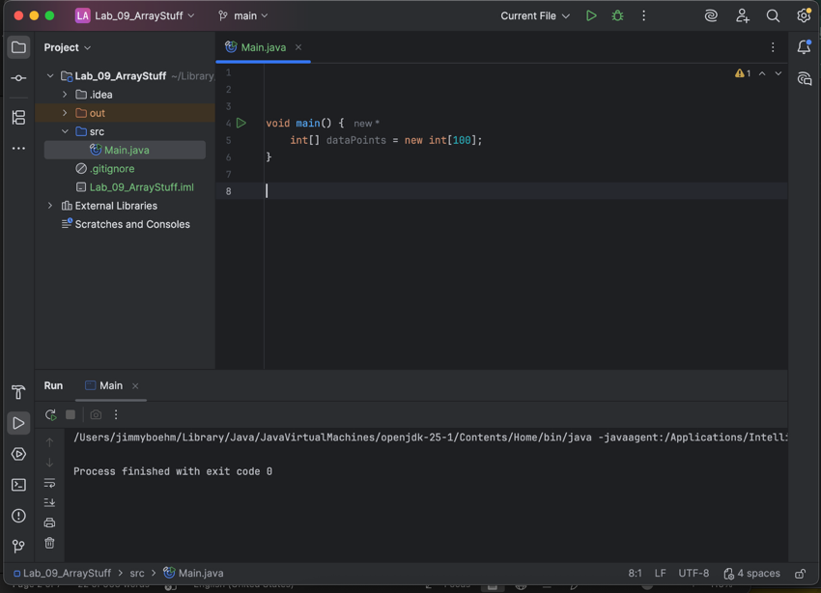

Task 2
Now, code a regular for loop that iterates through the dataPoints array and initializes each element in it to a random value between 1 and 100.
(See notes above for using java.util.Random. Please do not use Math.Random!)
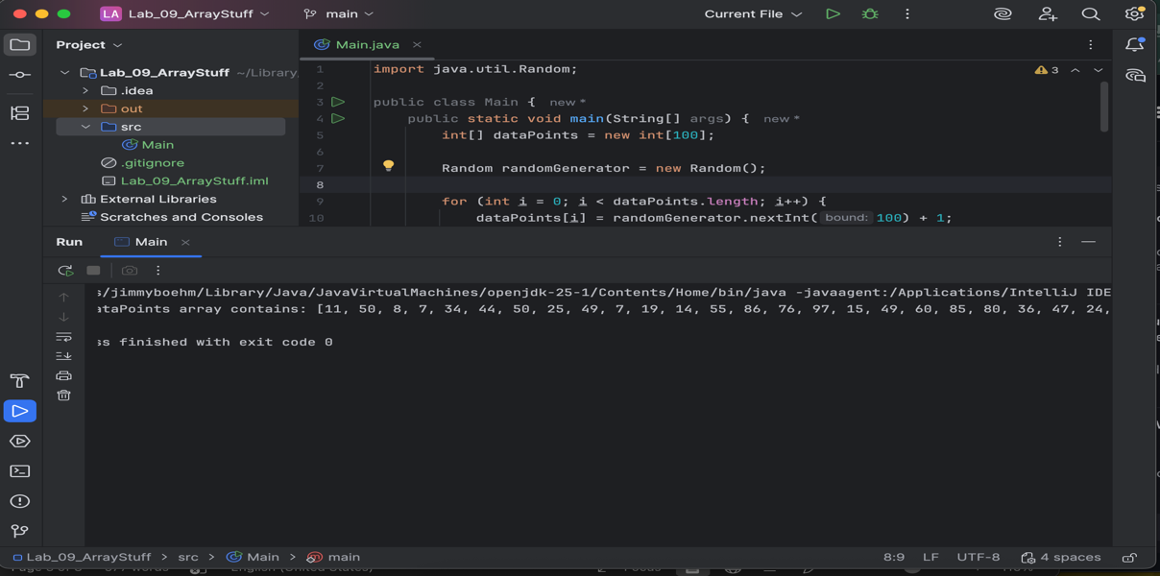

Task 3
Code a second loop that displays the dataPoints values like this (values are all on the same line and separated by " | " e.g. space, vertical bar, space):
val1 | val2 | val3 | HINT: use printf or System.out.print()
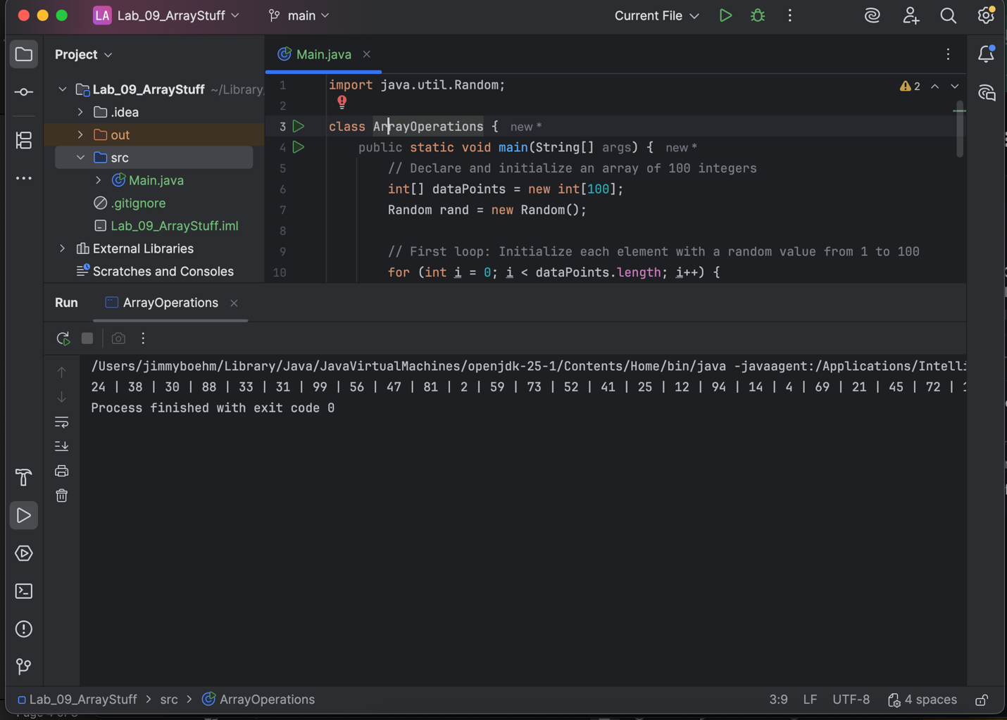

Task 4
Now, code a loop that calculates the sum and the average of the values in dataPoints.
Add code to output/display the sum and the calculated average. (Be sure to include some sort of description in the output so it is clear (i.e. use complete sentences). 'The average of the random array dataPoints is: ' or something similar. Don't just print out the average and sum as a raw numbers. (Do this for all the output here… just like you should in every program you code!)
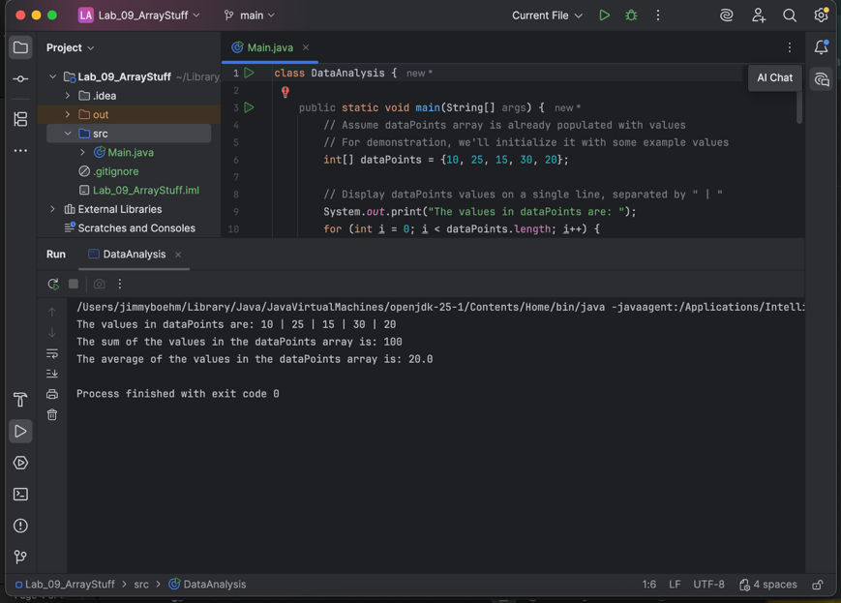

Part 2: Linear scan (search) (10pts)

Task 5
Add code to prompt and input an int value between 1 and 100 from the user. (Use your static getRangedInt(…) method from SafeInput from the last lab here! Just include your SafeInput.java Library file in the src folder of yourIntelliJ project and access your bullet-proofed input methods there. SafeInput.getRangedInt(…)
(No shots needed here.)

Task 6
Code a loop that iterates through the entire dataPoints array and counts how many times the user's value is found within the array. Indicate with a clear output statement how many times the loop found the user's value within the array. Remember that it might not find the value in the random set! Be sure to echo the value that the user had you search for in your feedback.
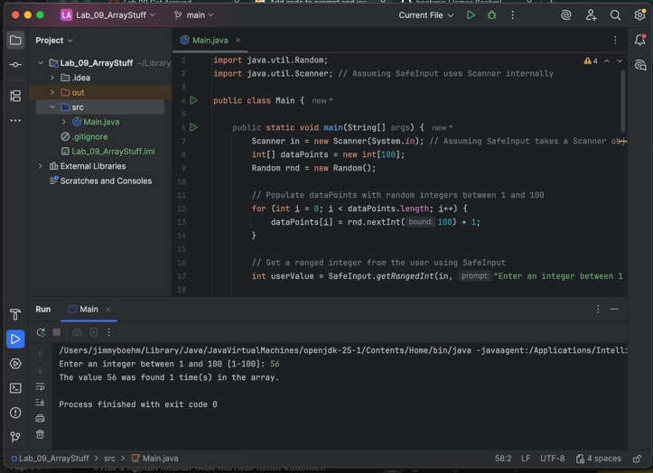

Task 7
Prompt the user again for a val between 1 and 100.
Code a loop that iterates through the dataPoints array checking each value to see if it matches the one the user input. This loop should short circuit (break) when it finds the value and displays the first position of the value within the array in a complete sentence.
Again, make the output clear and explicit here. (e.g. "The value VALUE was found at array index POSITION" where VALUE is the user's value you input and POSITION is the location (index) where the value is found in the array. If the value is not in the array, then the output statement should indicate that.
Note: You can use the break keyword to jump out of a loop before it completes. The problem here is that you have to keep track of whether or not the value was found at all.
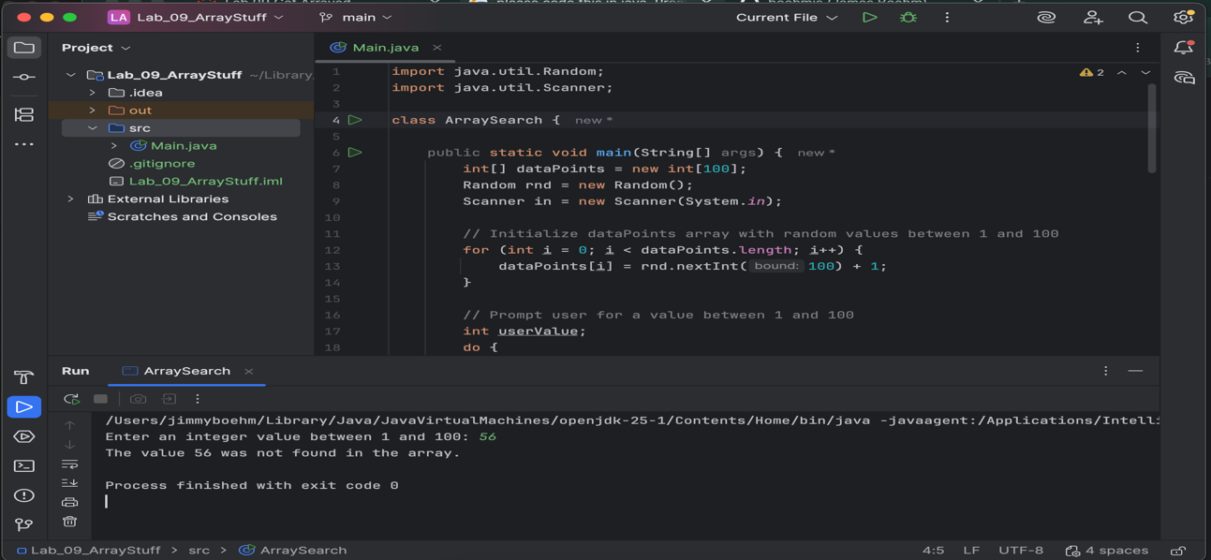

Task 8
Write a loop to scan for the minimum and maximum values in the dataPoints array. Display these values to the user.
Note: These might not be unique, there might be several occurrences of either the min or the max value in the random array.
Hint: You can assume initially that the first element is the min and max and iterate through the rest of the array to determine if there is a lower or higher value which then becomes the min or max respectively. You can also write a single loop that determines both the min and the max at the same time by checking both in this way.
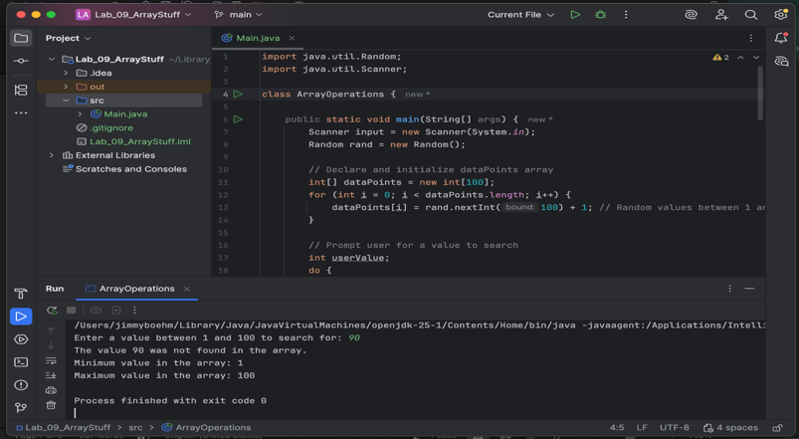

Task 9
Write this static method which takes an array of double values and returns the average and test it. Remember static methods go in the main java class file immediately after the main method.
public static double getAverage(int values[])
{
}
In your main code call it like this:
System.out.printLn("Average of dataPoints is: " + getAverage(dataPoints));
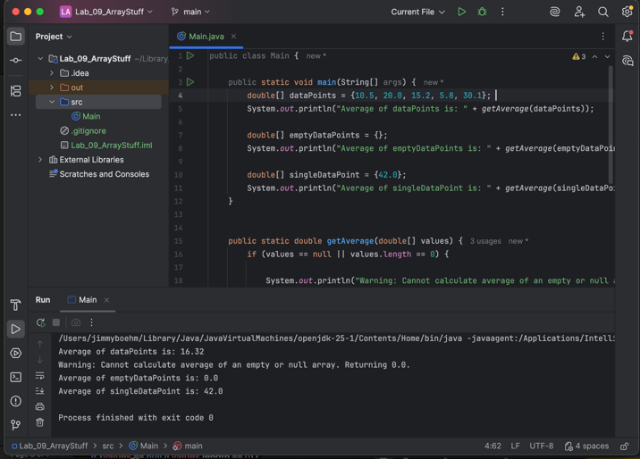

Post-Lab: Double-check Your Work
Now that you have completed the lab tasks, build constructive professional work habits by carefully rechecking your work, and abiding by the naming format and submission instructions.

Rename the file:
Use the YourLastname_YourFirstname_Lab09.docx format; remember to replace "YourLastname" and "YourFirstname" with your actual names.
The naming format will help us efficiently track and organize your files.

GitHub Link
https://github.com/boehmjs/Lab_09_ArrayStuff

Submit
Submit to Canvas using the assignments mechanism to upload your document. Don’t submit a link to your document.

